COLOURS/PATTERNS : SIENA
SIENA | Rococo | Plaspave 50 | Plaspave | Premia | Rococo Circle Kit
  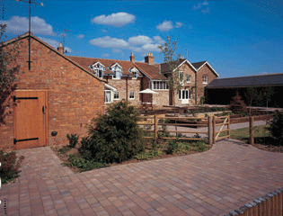
  Dimensions | Large | Medium | Small
  Thickness (mm) | 50 | 50 | 50
  Size (mm) | 246 x 164 | 164 x 164 | 123 x 164
  Pack Information
  Pack contents (units) | 240 | 400 | 480
  Pack coverage (m) | 9.68 | 10.75 | 9.68
  Pack weight (kg) | 1100 | 1200 | 1100
  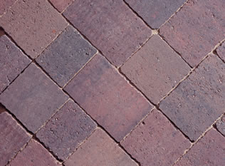
  Burnt Umber - 45 degree Herringbone
  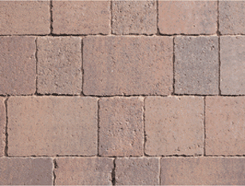
  Burnt Umber - 90 degree Running Bond

COLOURS/PATTERNS : ROCOCO
SIENA | Rococo | Plaspave 50 | Plaspave | Premia | Rococo Circle Kit
  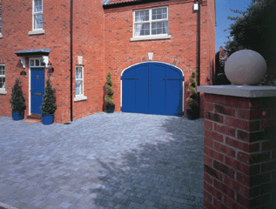  COLOUR / PATTERNS RANGES  - SIENA  - Rococo  - Plaspave 50  - Plaspave  - Premia  - Rococo Circle Kit
  Dimensions | Large | Medium | Small
  Thickness (mm) | 60 | 60 | 60
  Size (mm) | 240 x 120 | 160 x 120 | 80 x 120
  Pack Information
  Pack contents (units) | 96 | 192 | 48
  Pack coverage (m) | 7.61
  Pack weight (kg) | 950
  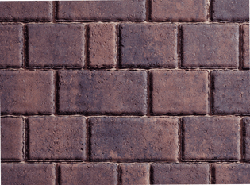
  Rustic Gold - 90 degree Running Bond
  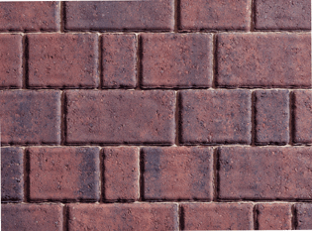
  Traditional Brindle - 90 degree Running Bond
  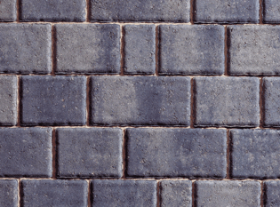
  Granite Stone - 90 degree Running Bond

